NYSSLS Daily Lesson Plan
Instructional Unit:  Weather and Climate –  Air masses, Fronts and Weather  Relative Humidity and Dew Point |  |  |  |  |  | Period(s) of Unit: |  | Date:
Materials/Resources/Links: |  |  |  |  |  |  |  | Course:
Special Notes for Lesson:

Standards:
Science and Engineering Practices  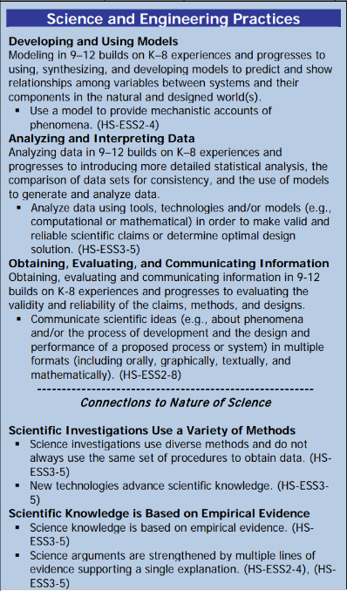 |  |  | Disciplinary Core Idea(s)  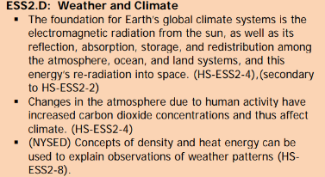 |  |  |  | Cross Cutting Concepts  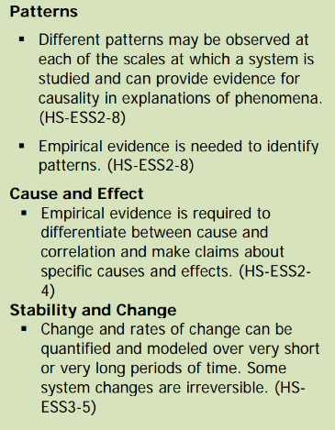
Performance Level
NYS Level 5 | NYS Level 4 |  |  | NYS Level 3 | NYS Level 2 |  |  | NYS Level 1
Collect and analyze global and regional weather data using tools, technologies, and /or models to communicate in multiple formats how the movement and interactions of airmasses result in changes in weather conditions. | Evaluate data and communicate information to explain hoe the movement and interactions of air masses result in changes in weather conditions |  |  | Evaluate data and communicate information to identify patterns of movement and/or the resulting changes in weather conditions. | Use data to identify the patterns of movement or the interactions of air masses and the resulting change in weather conditions  or to identify factors that drive the movement of air masses or from given weather conditions, identify evidence from maps that support these conditions. |  |  | Use data and/or patterns of movement and interactions of air masses to identify the resulting changes in weather conditions or identify one factor that drives the movement of air masses or from those provided, use evidence from maps to account for weather conditions or given weather conditions, identify evidence found on maps that account for one of these conditions.
Clarification Statement  . |  |  |  |  | Assessment Boundary
Connection to Anchoring Phenomenon:

Essential Question(s):

Instructional Strategies & Learning Tasks: Engage, Explore, Explain, Elaborate, Evaluate
Engage: images, video clip or data…

Explore: Students investigate, experiment, hands-on activity….
Explain: Students share their observations and evidence to explain their understanding…possible whole group/class discussion…

Elaborate: Students apply the science concepts they’ve just learned…

Evaluate (Formative Assessment): Student learning is evaluated.

Copy and paste student worksheets below:

